**Project Design Phase-II**

**Data Flow Diagram & User Stories**

|  |  |
| --- | --- |
| Date | 22 June 2025 |
| Team ID | LTVIP2025TMID56697 |
| Project Name | LearnHub: Your Center for Skill Enhancemen |
| Maximum Marks | 4 Marks |

**Data Flow Diagrams:**

A Data Flow Diagram (DFD) is a traditional visual representation of the information flows within a system. A neat and clear DFD can depict the right amount of the system requirement graphically. It shows how data enters and leaves the system, what changes the information, and where data is stored.



**Example:** [**(Simplified)**](https://developer.ibm.com/patterns/visualize-unstructured-text/)

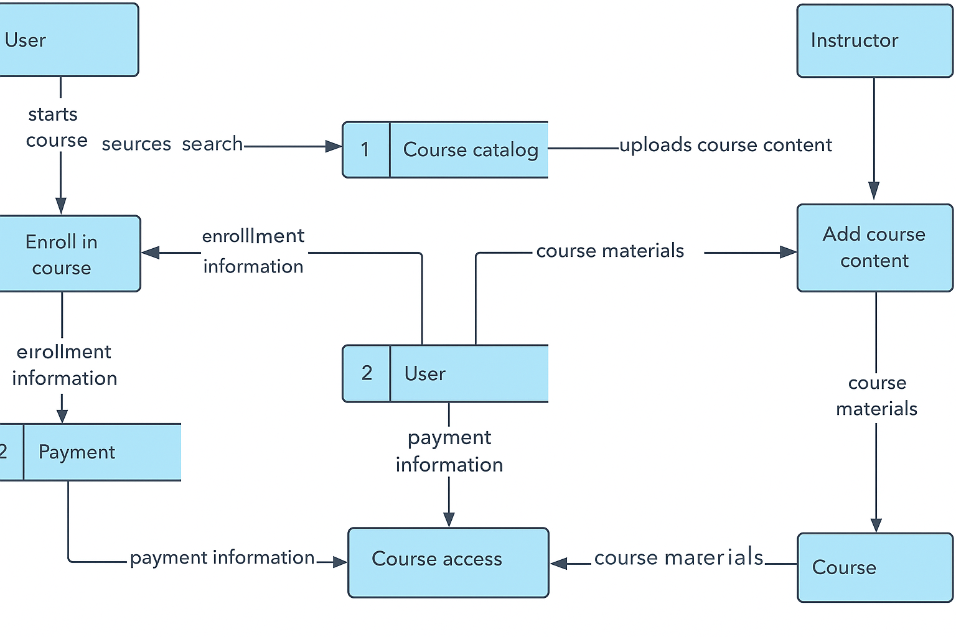

**User Stories**

Use the below template to list all the user stories for the product.

|  |  |  |  |  |  |  |
| --- | --- | --- | --- | --- | --- | --- |
| **User Type** | **Functional Requirement (Epic)** | **User Story Number** | **User Story / Task** | **Acceptance Criteria** | **Priority** | **Release** |
| Student (Web) | Registration | USN-1 | As a student, I can register using email and password | I can access my student dashboard after successful registration | High | Sprint-1 |
|  |  | USN-2 | As a student, I receive a confirmation email after registration | I get a confirmation email with activation link | High | Sprint-1 |
|  |  | USN-3 | As a student, I can register using Google (Gmail) | I can register and access dashboard using Google authentication | Medium | Sprint-1 |
|  | Login | USN-4 | As a student, I can login using email and password | I can access my dashboard after successful login | High | Sprint-1 |
|  | Dashboard | USN-5 | As a student, I can view enrolled courses and certificates | I see my enrolled courses, progress, and certificates | High | Sprint-2 |
| Teacher (Web) | Course Management | USN-6 | As a teacher, I can create, edit, and delete courses | Courses appear for students after publishing | High | Sprint-2 |
|  | Dashboard | USN-7 | As a teacher, I can monitor student progress and course stats | I see enrolled students, quiz stats, and course completions | Medium | Sprint-3 |
| Admin (Web) | User Management | USN-8 | As an admin, I can view, edit, or delete any user (student/teacher) | I can manage users from the admin panel | High | Sprint-3 |
|  | Course & Platform Monitoring | USN-9 | As an admin, I can see platform analytics and course performance | I view charts on usage, active users, and popular courses | High | Sprint-4 |
|  | Admin Login | USN-10 | As an admin, I can securely login and access admin-only features | Access granted only to admin credentials | High | Sprint-3 |
|  |  |  |  |  |  |  |
|  |  |  |  |  |  |  |